

*shell programming lab*

aSsignment -4

**SUBMITTED BY: SUBMITTED TO:**

**AYUSH KUMAR JHA Dr. Dhiviya Rose**

**SAP ID - 500086400**

**Enrollment no - R200220083**

**B.C.A -I.O.T.**

**EXPERIMENT – 4**

**TITLE:** Use of Shell Variables

**Activities:**

1. Differentiate between the environment and user-defined variables in shell programming.

**Environment variables** define the behavior of the environment. They can affect the processes ongoing or the programs that are executed in the environment. The name of the variable is case-sensitive. By convention, environment variables should have UPPER CASE names. When assigning multiple values to the variable they must be separated by the colon [: ] character. There is no space around the equals [ = ] symbol.

**User Defined variables** are variables that can be created by the user and exist in the session. This means that no one can access user-defined variables that have been set by another user, and when the session is closed these variables expire. User-defined variable names must be preceded by a single at[ @ ] character. These variables cannot be declared. They can be read even if no value has been set. Since user-defined variables' types cannot be declared, the only way to force their type is using CAST() or CONVERT().

2. List down the rules for the creation of variables, and print some environmental variables.

The rules of creating the variables are-:

1. The variable name has lower case letters.
2. No dollar sign “$” inserted while printing it.
3. Adding spaces after the initialization of the variable name and its value.
4. Start the variable name with a number, digit, or special symbols.

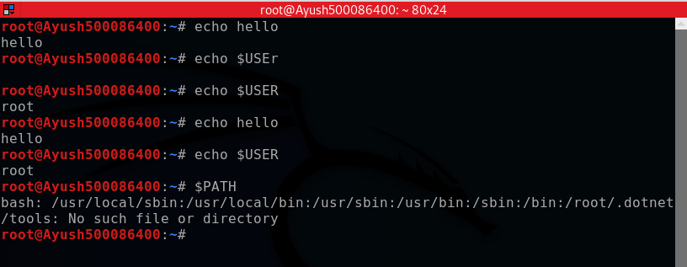

3. Write a program to fetch the command line arguments and print them in your shell script.

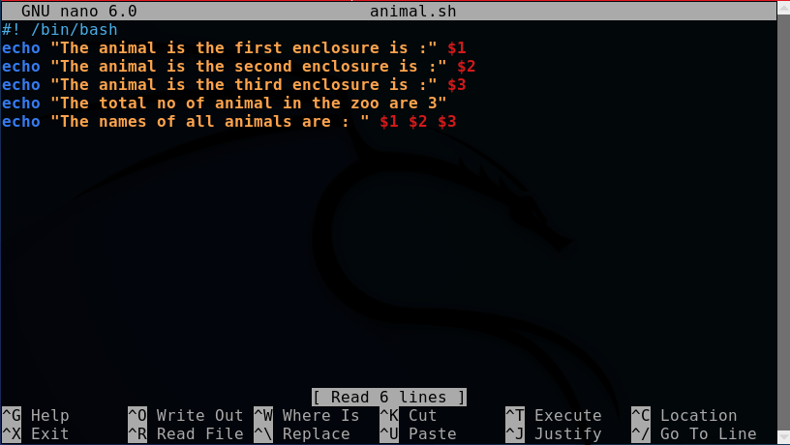

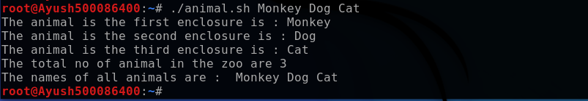

4. Write a program to get user input of 2 numbers, add and display.

